**Data Factory – Data set Configuration**

Dataset configuration

Update name and description for the Destination Dataset:

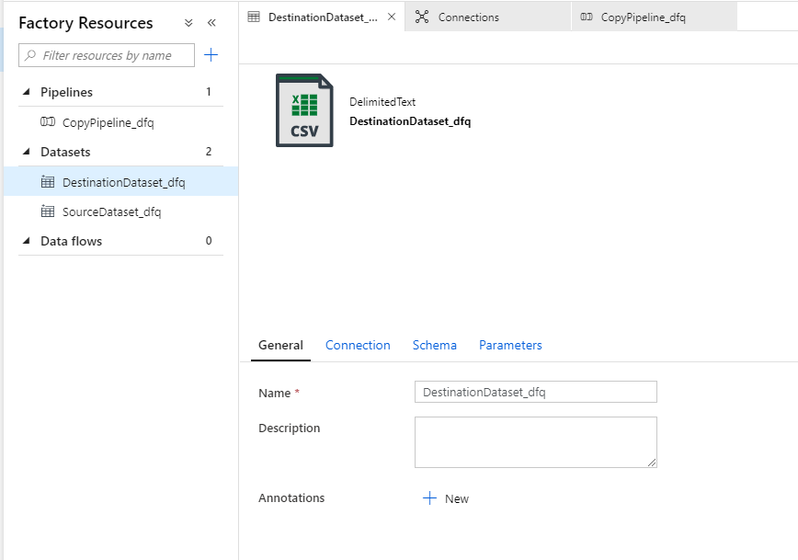

Update connection information. In this example, it’s a storage account so fill in the path, delimiter info, and other details:

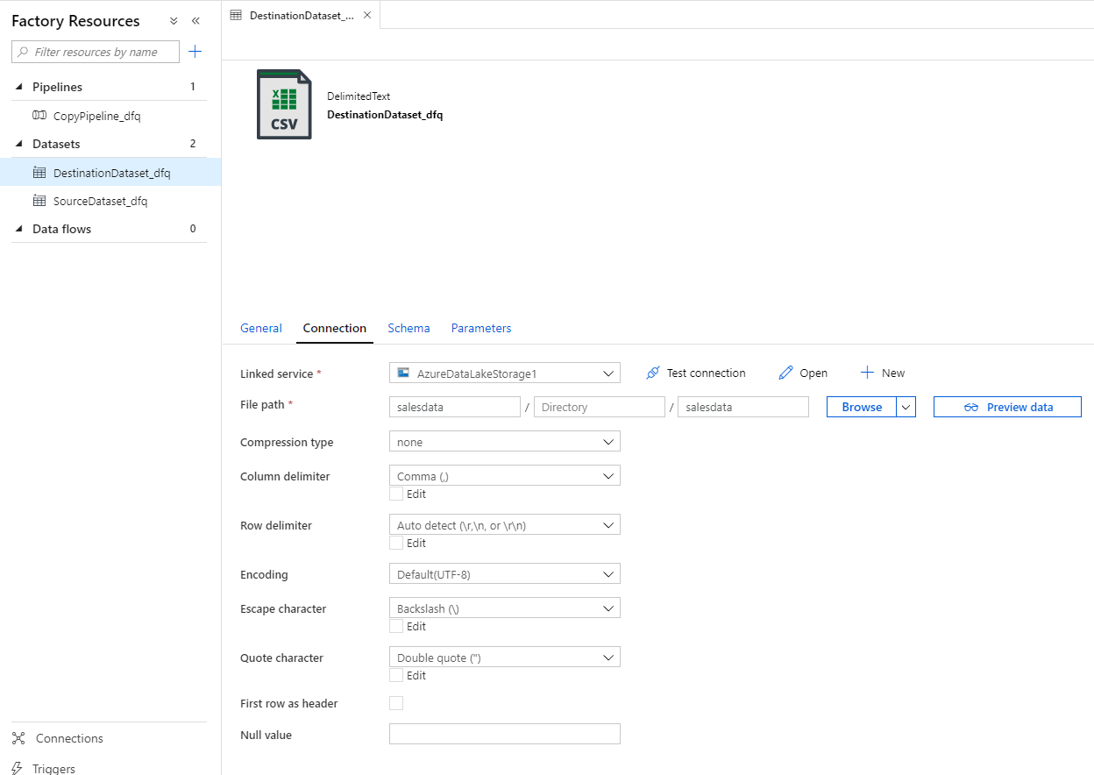

Test the connection to ensure the data service can be accessed based on the configuration.

For the storage account dataset, we will not change the Schema settings:

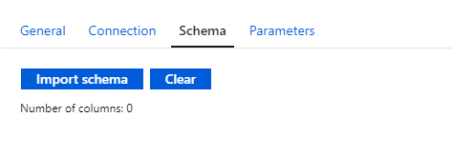

For the storage account dataset, we will not change the Parameters settings:

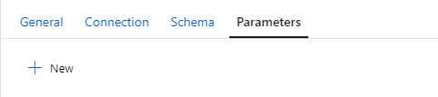

Update name and description for the Source Dataset:

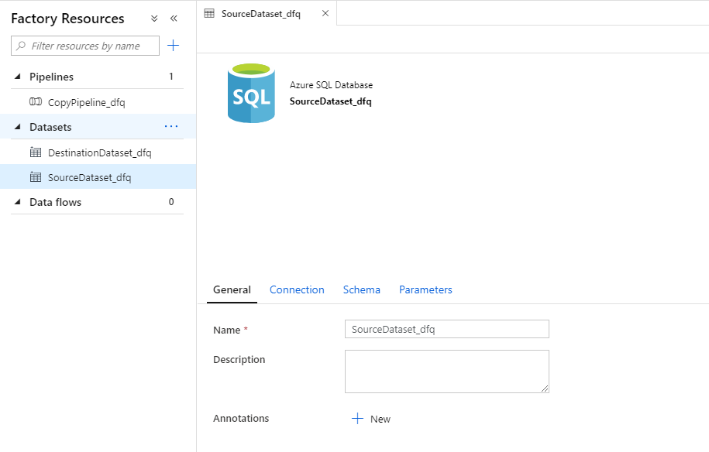

Configure the linked service. In this example, we are linking to a SQL Server database. Test the connection to confirm details are correct.

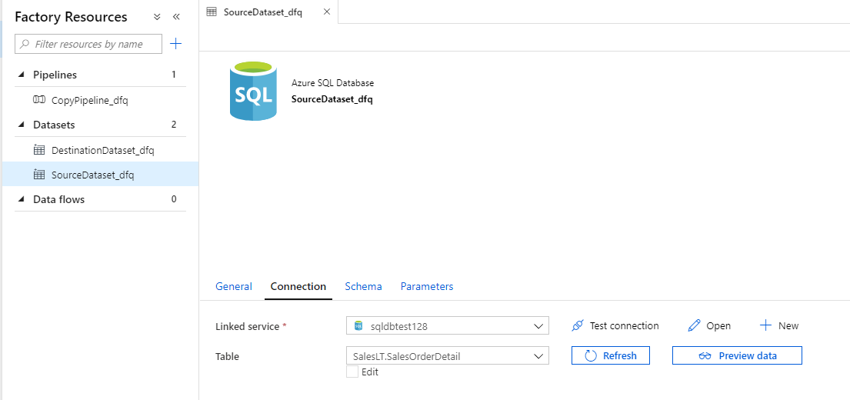

The schema is imported from the table:

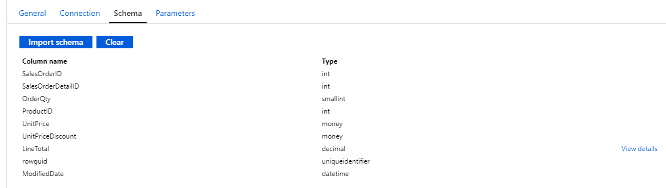

No changes to the Parameters tab for this example:

